

UNIVERSITY COLLEGE DUBLIN

Master of Science (Business Analytics)

MIS41120-Statistical Learning

**Practical Data Analysis Assignment**

Supervisor: Sean McGarraghy

TeamNumber: 29

Baizhou Tao (19211033)

BoTao Gao (19208319)

Statement: All things submitted are all our own work

Contribution: Baizhou Tao: LR coding and report writing

Contribution: Botao Gao: MLP coding and report writing

16 July 2021

Introduction

In this experiment, we use linear regression and mutilayer perceptron (MLP) with three regularization methods LASSO, Ridge, Elastic Network to implement crime rate prediction on Boston dataset and House price prediction on a house price dataset. We use python as a data analysis tool, here is the list of python frameworks used: PyTorch, pandas, sklearn, NumPy, matplotlib, statsmodels, seaborn, scipy, os, warnings. The folowing content is organized as follows: section 1 introduces the methodology and shows the performance of linear regression with different regularization terms. The methodology and performance of MLP are demonstrated in section 2. The comparison of two types of models is shown in the section 3.

1. Linear Regression

1.1 Methodology

We quote here p to indicate the number of predictors, and n to instances. Both two kinds of datasets are n>>p. Compared with the simple linear regression model, it has the advantage that it can directly include multiple predictors and give each predictor a separate slope coefficient. The regression model is as follows.

$$Y=β_{0}+β_{1}X_{1}+β_{2}X_{2}+…+β_{p}X_{p}+ε$$

To estimate the standard linear regression model, we use the compressed estimation method. Compared with least squares estimation, compressed estimation uses regularization to compress the estimated coefficients toward 0, reducing variance and increasing model stability. So, we use three regularization methods (Lasso regression, Ridge regression and elastic net) for variable selection and model optimization.

Ridge regression: Ridge regression is obtained by minimizing the Sum of RSS and L2 penalty terms. Among them, λ≥0 is an adjustment parameter, which is determined separately, and its function is to control the relative influence of these two items on the estimation of the regression coefficient. The influence of the compression penalty term increases as λ becomes larger, so it is very important to choose an appropriate λ value.

Lasso: It obtains a more refined model by constructing an L1 penalty term, which makes it compress some regression coefficients, that is, force the sum of absolute values of coefficients to less than a certain fixed value. At the same time, set some regression coefficients to be zero. Therefore, the advantage of subset shrinkage is retained, and it is a biased estimate for processing data with multicollinearity.

Elastic Net: The elastic net utilizes the linear additivity of lasso regression and ridge regression. When L1 term is 0, it is ridge regression, and when L2 is 0, it is lasso regression. We use the formulation rewrite by James et al. (2013) as follows and use hyperparameter alpha to design regularization.



* 1. Boston crime rate prediction

In the experiments, we choose the suitable parameter alpha through grid search and get the best parameter via 5 fold validation, which can help us to find optimal alpha-value to improve the performance of the model on the test datasets. And the brief results can be seen in table 1. The details such as reports and results are shown in the code and Github. Only examples here will be discussed.

|  |  |  |  |  |
| --- | --- | --- | --- | --- |
|  | LR | LASSO | RIDGE | Elastic Net |
| L1 weight | 0 | 1 | 0 | 0.1 |
| L2 Weight | 0 | 0 | 1 | 0.9 |
| Alpha | 0 | 0.0001 | 0.01 | 0.01 |
| MSE on training data | 0.24 | 0.2351 | 0.2356 | 0.2335 |
| MSE on testing data | 0.2390 | 0.2378 | 0.2428 | 0.2406 |

Table 1: Performance of Linear models

As it is shown in the table 1, the three regularization methods have improved the accuracy of the model, which shows that the regularization method we used in this experiment is effective. As for the results of MSE on the test dataset, Lasso regression is the superior one, it has the loss.

In addition, we rely on statsmodel package to generate statistical reports that can help us determine which predictors can reject the null hypothesis. Besides that, the number of instances in the Boston dataset is much greater than the number of predictors, so we can judge whether the predictor can reject the null hypothesis with p value that is smaller than 0.05.



Taking LR's report as an example, as it is shown in the table 2, predictors with the p value less than 0.05 are x1, x7, x8, x11,x12, and the corresponding variable names are ‘zn’, ‘nox’, ‘dis’, ‘lstat’, ‘medv’. The same discrimination method can also be applied to the statistical reports from table 3, 4, and 5 of LASSO, Ridge and elastic net regularization.

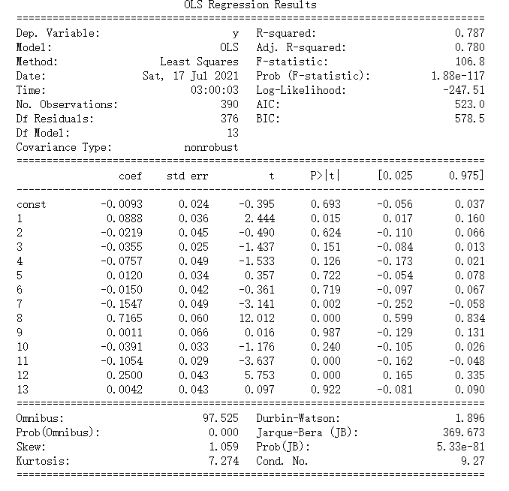

Table 2: Report of Linear regression

Table 3: Report of Linear regression with Lasso

Table 4: Report of Linear regression with Ridge regularization

Table 5: Report of Linear regression with Elastic Net regularization

From the above reports, we can also observe the sparsity of L1 regularization and elastic net, which set some of the coefficients to be zeros.

* 1. House price prediction

Compared to the dataset of Boston, there are some differences between them. These changes mean different datasets can lead to different model selections. We try a dataset with more predictors. After the data cleaning and exploratory data analysis, there are 23 predictors used to train a regression model. The results are listed in the table 6:

|  |  |  |  |  |
| --- | --- | --- | --- | --- |
|  | LR | LASSO | RIDGE | Elastic Net |
| L1 weight |  | 1 | 0 | 0.1 |
| L2 Weight |  | 0 | 1 | 0.9 |
| Alpha |  | 0.0001 | 0.01 | 0.01 |
| MSE on training data | 0.2457 | 0.2347 | 0.2339 | 0.2319 |
| MSE on testing data | 0.1544 | 0.1670 | 0.1527 | 0.1636 |

Table 6: Performance of Linear Regression with different regularization

Comparing the training results of the boston and house price data sets, the two datasets rely on different regularization methods to obtain the optimal model. This is because in the house price data set, there are many predictors with high multicollinearity. When faced with multiple variables with high collinearity, lasso will randomly select one of the variables and ignore the others, which will reduce the strength of the regularization.

In addition, we also generate the statistical reports of linear models with different regularization terms running on the house data set. Since n>>p, we can think that a predictor with a p value less than 0.05 can reject the null hypothesis. The results are shown in the table 7, 8, 9, 10.

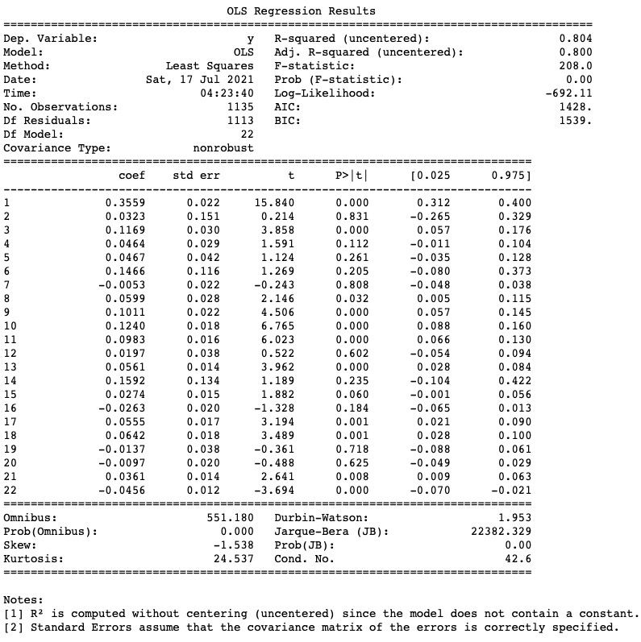

Table 7: Report of Linear regression on house price dataset

Table 8: Report of Linear regression with Lasso on house price dataset

Table 9: Report of Linear regression with Ridge regularization on house price dataset

Table 10: Report of Linear regression with Elastic Net regularization on house price dataset

2. MLP

2.1 Methodology

In this section, the effects of multilayer perceptron (MLP) models with various regularization terms (L1, L2 and Elastic net) on both Boston dataset and House Price dataset are demonstrated. MLP is inspired by the neuron network of the brain, which receives the inputs from the environment and outputs the actions. Different from the linear model in this assignment, MLP has better model flexibility such that it is able to resolve non-linear problems.

The fully connected MLP model we use contains 13 neurons in the input layer since there are 13 predictors in the Boston dataset (22 neurons on House Price dataset) and one hidden layer with 100 neurons. The output layer only contains one neuron because the regression problem only needs one neuron to output the values. The loss function we use is the same as the formula in statsmodel package:



Where L1_wt is the percentage of L1 regularization and (1 - L1_wt) is the percentage of L2 regularization. Thus, when L1_wt is 1 the regularization is L1 regularization and when L1_wt is 0 the regularization is L2. When L1_wt is between 0 and 1, it is elastic net regularization. Alpha is the weight of regularization terms. The models and all the training processes are developed by PyTorch.

During the experiments, we only change and tune the following parameters: L1_wt, alpha. For each dataset, one parameter (batch size) is tuned for seeing if the batch size can improve the learning performance. The other default parameters of MLP are set as follows:

Optimizer: Stochastic gradient descent (SGD)

Activation function: Rectifier Linear Units (ReLu)

Learning Rate: 0.001

Momentum: 0.8

Batch size: 98

Early stop: 200

The details of models and configurations can be seen in the Jupyter notebook file MLP.ipynb.

2.2 Boston dataset

For comparing the performance of MLP on the Boston dataset, we keep all the data preprocessing the same as in the linear regression model.

The performance of MLP and MLP with different regularization terms is tested by splitting the Boston dataset into 5 different training and validation combinations with 5 different random seeds. The performance of each model is evaluated by the mean of 5 MSEs.

The regularization parameters are decided by random search, which tests different parameters by examining the loss. The performance of the MLP models with different regularization parameters is shown in Table 11.

|  |  |  |  |  |
| --- | --- | --- | --- | --- |
|  | MLP | L1 | L2 | Elastic Net |
| L1 weight | 0 | 1 | 0 | 0.2 |
| L2 Weight | 0 | 0 | 1 | 0.8 |
| Alpha | 0 | 0.01 | 0.05 | 0.1 |
| Mean MSE | 0.1914 | 0.1850 | 0.1811 | 0.1789 |
| STD of MSE | 0.057 | 0.146 | 0.061 | 0.062 |

Table 11: Performance of MLP on Boston dataset with different regularization

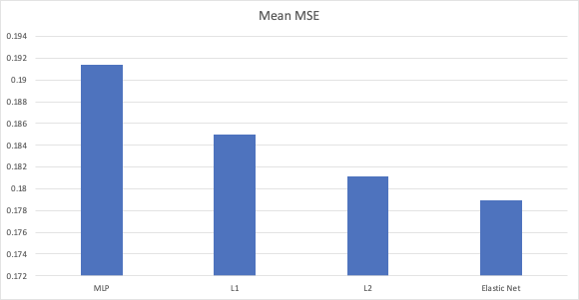

Figure 1: Performance of MLP on Boston dataset with different regularization

As it is shown in the figure 1, the mean MSEs are lower when the penalty terms are added into the loss function. The reason for this result is that the risk of overfitting is reduced by adding the regularization terms. Therefore, the generalization ability is improved by restricting the models that learn well. Elastic net regularization term performs best which reduces 6.5% of MSE compared to the MLP without penalty term.

2.3 House price

The performance of MLP with various penalty terms is shown in table 12.

|  |  |  |  |  |
| --- | --- | --- | --- | --- |
|  | MLP | L1 | L2 | Elastic Net |
| L1 weight | 0 | 1 | 0 | 0.52 |
| L2 Weight | 0 | 0 | 1 | 0.48 |
| Alpha | 0 | 0.07 | 0.03 | 0.003 |
| Mean MSE | 0.1748 | 0.1554 | 0.1530 | 0.1488 |
| STD of MSE | 0.089 | 0.098 | 0.095 | 0.098 |

Table 12: Performance of MLP on Boston dataset with different regularization

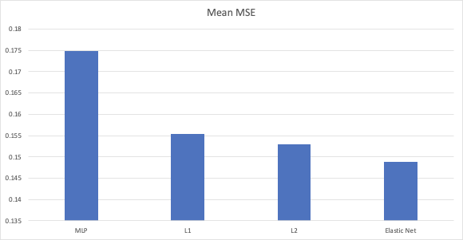

Figure 2: Performance of MLP on house price dataset with different regularization

As it is shown in table 12 and figure 2, with the regularization terms, the MSE on the testing datasets is significantly decreased. By using the Elastic net penalty method, the mean MSE is reduced by 14.8%.

Since the non-linear and black box property of MLP, we are not able to get the coefficients of each predictor and evaluate if we can reject the null hypothesis.

3. MLP vs Linear regression

From the table 13 and 14 we can see that with any regularizaiton method MLP models always achieve lower loss compared to linear regression. MLP with elastic net regularization is always the superior model since it leads to the lowest MSE on the testing dataset of two datasets. This is because the non-linear property of MLP provides a better flexibility to performs better on the datasets where the target feature and the input features are not linear. However, this superior performance may varied in different datasets. LR is the most simplified version of MLP, with only input and output layers and no hidden layers. MLP has a higher advantage in processing high-latitude data but in an easier dataset, MLP has higher risk to be overfitting. In addition, MLP may sacrifices the interpretability since it is a almost black box that we cannot explain model like linear regression model. The interpretability of the MLP sacrifice lies in the high-latitude spatial mapping of the hidden layer.

|  |  |  |  |  |
| --- | --- | --- | --- | --- |
|  | No Regularization | L1 | L2 | Elastic Net |
| Linear Regression | 0.2362 | 0.2351 | 0.2356 | 0.2335 |
| MLP | 0.1914 | 0.1850 | 0.1811 | 0.1789 |

Table 13: Performance of linear model and MLP on Boston dataset

|  |  |  |  |  |
| --- | --- | --- | --- | --- |
|  | No Regularization | L1 | L2 | Elastic Net |
| Linear Regression | 0.2457 | 0.2347 | 0.2339 | 0.2319 |
| MLP | 0.1748 | 0.1554 | 0.1530 | 0.1488 |

Table 14: Performance of linear model and MLP on house price dataset

Reference

James, G., Witten, D., Hastie, T. & Tibshirani, R. 2013, An introduction to statistical learning: with applications in R, Springer, New York.

Oneto, L., Ridella, S. & Anguita, D. 2016, "Tikhonov, Ivanov and Morozov regularization for support vector machine learning", Machine learning, vol. 103, no. 1, pp. 103-136.

Paszke, A. et al., 2019. PyTorch: An Imperative Style, High-Performance Deep Learning Library. In *Advances in Neural Information Processing Systems 32*. Curran Associates, Inc., pp. 8024–8035. Available at: <http://papers.neurips.cc/paper/9015-pytorch-an-imperative-style-high-performance-deep-learning-library.pdf>.

Appendix:

Code on Github, Available at: https://github.com/angrymushroom/SL_Assignment

Data source, Available at: https://www.kaggle.com/c/house-prices-advanced-regression-techniques/data